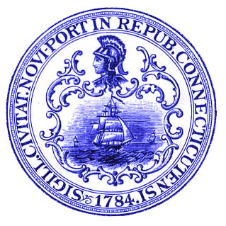
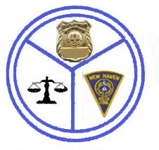
NEW HAVEN
DEPARTMENT OF POLICE SERVICE
One Union Avenue • New Haven • Connecticut • 06519

Francisco Ortiz Jr.
Chief of Police
John DeStefano Jr.

Mayor

NEWS RELEASE

FOR IMMEDIATE RELEASE

Thursday, 31,August 2006

EVENING VIOLENCE LEAVES ONE DEAD

NEW HAVEN – At 22:01, police responded to 20 York St after the hospital reported a gunshot victim had been driven there by private car. Officers spoke to the victim Calvin Franklin 16 of Howard Ave who stated, he was standing in the front of 43 Orchard St when he heard gunshots and then realized he had been shot. He sustained non life threatening injuries.

At 22:11 police responded to 75 Frank St where they found Lawrence “ Little Larry” Mabery with a gunshot wound to the head. While emergency personnel were attending to Mabery they found two loaded hand guns on his person. He was transported to Yale New Haven Hospital where he was later pronounced dead. Assistant Chief Herman Badger stated “ let it be clear this shooting was not a random act of violence, Mabery’s life style placed him in a high risk category”. Police were looking for a small silver car with two black males which were possibly involved.
During the early stages of this investigation, detectives had applied for a murder warrant for Mabery in connection with the Domingo Rodriquez shooting on July 12th 2006 on Greenwich Ave. Also arrested for the Rodriquez shooting are, Patrick Mims 20, and John Williams 21, of New Haven.

At 23:47, police also responded to 437 Eastern Street on report of gunshots. Upon arrival they found two subjects, Dustin Parker 18, shot in the right forearm and Hernandez Ortiz 19 shot in the left hand. This investigation is continuing

Contact: Officer Joseph Avery
(203) 946-5915

