Dreamdesk

A proposal for the East Rock School June 24, 2011
City of New Haven Percent for Art Program
By Paul Villinski

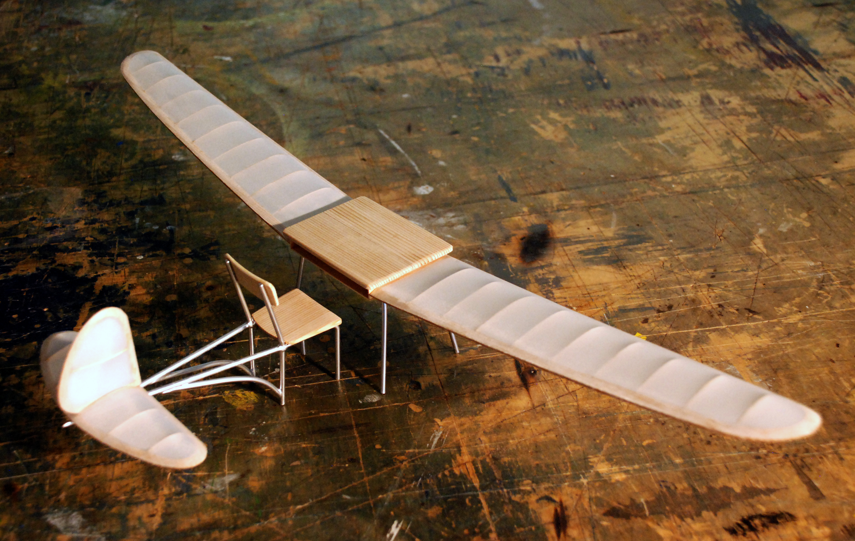

Concept:

A “flying desk” will be suspended overhead in the rear entranceway to the school.
(An alternative location is the school cafeteria.)

- Flight is a universal symbol of freedom, striving, achievement, grace and tranquility. It is a symbol that is well understood by children of all ages. The widely felt human desire to fly is evidenced throughout our culture, particularly in literature and popular music, where metaphors of flight and soaring are ubiquitous.

- The school desk is a place for concentration, focus, the development of critical and intellectual skills, and for discovering the contribution each child makes within the community – a place for work.

- Dreamdesk unites these two ideas, suggesting that WORK is what makes FLIGHT possible. We work hard to attain our goals, to build a solid foundation for our hopes, to make our way toward our dreams, to soar in our lives.

- Students of East Rock School will be invited to contribute a page of their homework for the sculpture. Pages will collaged onto the wing and tail surfaces, entirely covering them. The flying machine’s wings, comprised of the work of hundreds of students, will further develop the idea that the work of our hands and minds is what lifts us toward our dreams. This involvement will also give students a sense of “ownership” in the sculpture.

- The empty chair in Dreamdesk is an invitation for the viewer to use her imagination to take a seat in the flying machine, and set off on an aerial adventure. The wings are connected to the desk, and the tail is connected to the chair; it is the occupant of the chair who, leaning over the desk, connects the two elements. The children are asked to “complete” the artwork by imagining themselves seated at the desk.

- Dreamdesk will be suspended overhead in a climbing attitude with wings slightly banked, to communicate a feeling of ascending. The proposed location in the rear entranceway will allow the sculpture to be viewed from both above and below.

- The desk and chair will be an actual, vintage set from the New Haven Public School System. The wear and “patina” of use will be retained in the sculpture. In this way, Dreamdesk will carry an older, traditional element of the school environment into the new, state-of-the-art environment of the East Rock School.

Technical Information:

Materials: A vintage school desk and chair from the New Haven Public School System will be the basis of the sculpture. The wings and tail will be a hand-made, elaborately built-up wooden structure, covered with stretched polyester aircraft fabric which will refer to traditional aircraft construction. The fabric aircraft covering will be applied to the top surface of the wings and tail, so that the detailed structures of wings and tail will be revealed from below. Pages from students’ homework will be collaged onto the wing and tail covering on both the upper and lower surfaces with polyvinyl acetate (PVA) adhesive and sealed with polymer ultra-violet-filtering matte varnish. The tail section will be connected to the chair with an elegant, welded steel structure (“fuselage”), painted to match the steel legs of the desk and chair.

Durability: All materials will be extremely durable and all methods of fabrication will be in keeping with best practices for said materials, resulting in a sculpture with an expected lifetime of at least 100 years.

Dimensions: Approximately 21’ (wingspan) x 9-1/2’ (length) x 4’ (height).
Approximate weight: 90 lbs.

Installation: The sculpture will be suspended from the ceiling from four points with slender, extremely strong stainless steel cable, with swaged connections. Breaking strength of each of the four cables will be approximately 2000 lbs. Artist will coordinate with architect to determine exact locations of hanging points to ensure adequate structure in the ceiling for installation. Installation will require a scissor lift and will be accomplished by the artist’s team in one day.

Maintenance: Sculpture will require periodic dusting with a feather duster or compressed air; depending on indoor air quality, intervals may be several years between dustings. Dusting can be accomplished by standing on an A-frame ladder. No other maintenance is anticipated.

Estimated Timeline:

Final Designs/Drawings: 4 weeks
Fabrication: 16 – 20 weeks
Installation: 1-2 days

Estimated Budget:

Artist’s Fee: $5000
Materials: $5000
Fabrication Fee: $22,000
Travel to site: $1000
Transportation: $600
Installation (including site preparation): $5000
Lighting, Framing, or other “proper presentation costs” $4000
Studio and Operation costs: $2500
Insurance: $1200
Photographic Documentation: $1200
Public Report: $60
Identification Plaque: $600
Other: (contingencies) $2000
_______

Total; $50,160

Artist Biography
Paul Villinski is a professional visual artist who has created studio and large-scale artworks for more than three decades. Paul Villinski Studio, Inc. has three full-time, accomplished studio assistants who help realize large-scale projects, and employs other skilled technicians on an as-needed basis. Assistant Gregg Wagner (Head of Implementation) is a professional architect, whose expertise comes into play when executing public art projects.
Villinski was born in York, Maine in 1960, and has lived and worked in New York City since 1982. A “scenic route” through the educational system included stops at Phillips Exeter Academy and the Massachusetts College of Art, and a BFA with honors from the Cooper Union for the Advancement of Science and Art in 1984. He lives with his partner, the painter Amy Park, and their son, Lark, in their studio in Long Island City, NY.
His work has been included in numerous exhibitions nationally, recently including: “Second Lives: Re-purposing the Ordinary” at the Museum of Arts and Design, New York and “Prospect .1”, an international Biennial in New Orleans. “Emergency Response Studio,” a FEMA trailer redesigned and rebuilt into a solar-and wind-powered mobile artist’s studio, was the subject of a solo exhibition at Rice University Art Gallery, Houston; the exhibition also travelled to Ballroom Marfa, in Marfa, TX, and Wesleyan University’s Zilkha Gallery, Middletown, CT.
His work is widely collected, including major public works created by commission. He has been a recipient of a National Endowment for the Arts grant, and has been an Artist-in-Residence at the Serenbe Institute, (GA); the Millay Colony (NY); the Ucross Foundation (WY); the Djerassi Foundation (CA) and the Villa Montalvo Arts Center (CA). He is represented in New York by Morgan Lehman Gallery, in New Orleans by Jonathan Ferrara Gallery, and in California by Imago Galleries.
A pilot of sailplanes and paragliders, metaphors of flight and soaring often appear in his work. With a lifelong concern for environmental issues, his work frequently re-purposes discarded materials, effecting surprising and poetic transformations.

