CITY OF NEW HAVEN

BOARD OF ALDERMEN

Douglas Hausladen 161 Park Street, #1A
Alderman, 7th Ward New Haven, CT 06511-4807
____________ ________________

Member Telephone: (203) 309-2737
Education Committee E-mail: Ward7@newhavenct.net
Finance Committee
Public Safety Committee
Ad Hoc Living Wage Commission
Capital Projects Committee

October 30, 2012

Honorable Jorge Perez
President, New Haven Board of Aldermen

Dear President Perez:

I would like to respectfully submit to the Board of Aldermen as a Communication, the attached Order calling for a public hearing and workshop with the Acting City Assessor and his staff to discuss the process and methodology for determining real estate assessments.

Property owners in our city have expressed interest in gaining a better understanding of how the New Haven Assessor’s Office determines the value of real estate for taxation purposes. It would be very helpful to this Board and to the residents of New Haven to have the Acting City Assessor and his staff explain the process and methodology they utilize in valuing real property.

The discussion should focus on how residential properties are assessed, as well as on how commercial properties are assessed, with an explanation of the formula for evaluating income producing properties.

Such open and transparent discussion with Acting City Assessor Alex Pullen, and such members of the Assessor’s staff as he shall designate, before an appropriate Aldermanic committee on this topic of vital concern to so many city residents would do much to increase understanding and promote clear communication and cooperation between the city’s tax offices and New Haven taxpayers.

Thank you for your consideration of this submission.

Respectfully submitted,
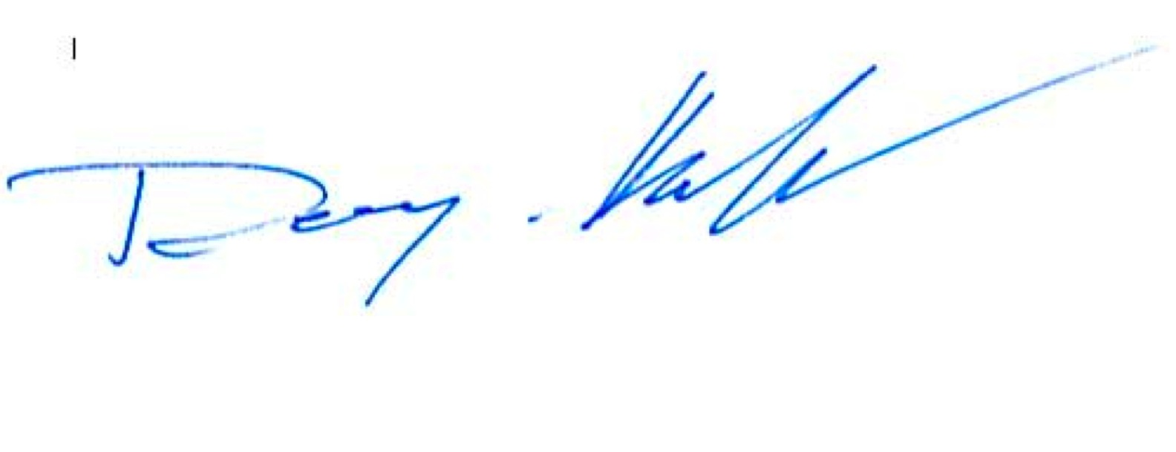
DOUGLAS HAUSLADEN
Alderman, 7th Ward

ORDER OF THE NEW HAVEN BOARD OF ALDERMEN CALLING FOR A PUBLIC HEARING AND WORKSHOP WITH THE ACTING CITY ASSESSOR AND HIS STAFF TO DISCUSS THE PROCESS AND METHODOLOGY FOR DETERMINING REAL ESTATE ASSESSMENTS.

WHEREAS: Property owners in our city have expressed interest in gaining a better understanding of how the
New Haven Assessor’s Office determines the value of real estate for taxation purposes; and

WHEREAS: it would be very helpful to this Board and to the residents of New Haven to have the Acting City Assessor and his staff explain the process and methodology they utilize in valuing real property; and

WHEREAS: the discussion should focus on how residential properties are assessed, as well as on how commercial properties are assessed, with an explanation of the formula for evaluating income producing properties; and

WHEREAS: such open and transparent discussion before an appropriate Aldermanic committee on this topic of vital concern to so many city residents would do much to increase understanding and promote clear communication and cooperation between the city’s tax offices and New Haven taxpayers.

NOW, THEREFORE, BE IT ORDERED that in order to promote a better understanding of the city’s methods in valuing real property for tax purposes, the New Haven Board of Aldermen will conduct a public hearing and workshop with Acting City Assessor Alex Pullen, and such members of the Assessor’s staff as he shall designate, to discuss the process and methodology for determining how residential properties are assessed, as well as how commercial properties are assessed, with an explanation of the formula for evaluating income producing properties.

