


Eagle Expectations

At Lincoln-Bassett,
We SOAR!

S | afe  We maintain the safety of our school community.
O | n-task  We focus on the task at hand, and are ready and eager to learn.
A | ccountable  We are responsible for our attitudes and actions.
R | espectful  We respect ourselves and others, and embrace our differences.


Eagle Expectations

At Lincoln-Bassett, We SOAR!

In the Classroom
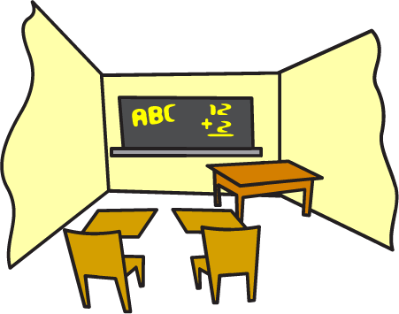 | - Respect your teacher and classmates  - Be accepting and kind to others  - Listen carefully and raise your hands to ask a question  - Come to class prepared with homework and supplies
In the Hallways
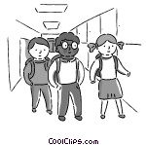 | - Stay in line and walk at a calm pace  - Keep your hands to yourself  - Use inside voices  - Follow directions
In the Cafeteria
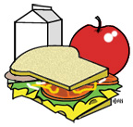 | - Enter quietly and be seated  - Get everything you need before you sit down  - Use inside voices  - Clean up your area
On the Playground
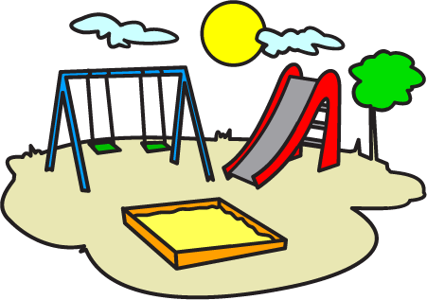 | - Play safely  - No pushing/shoving  - Share and take turns  - Keep your hands and feet to yourself
On the School Bus
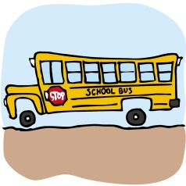 | - Stay seated  - Obey the driver  - Use inside voices  - Put your backpack on your lap
In the Restroom
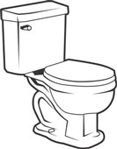 | - Keep your eyes and hands to yourself  - Respect privacy  - Report misuse  - Wash your hands

Lincoln-Bassett Behavior Response Plan

 | Level 1: Minor Infraction | Level 2: Moderate Infraction | Level 3: Severe Infraction
Definition: | Minor sign of disrespect that may disrupt the learning of self and/or others. | Moderate and intentional disruption and/or sign of disrespect that disrupts learning. | Significant and intentional disruption that compromises the safety of self and/or others.
Sample Behaviors: | - Calling out, disruptive behavior, or talking/nonverbal communication at inappropriate times  - Not following staff instructions  - Noncompliance with the uniform policy  - Unexcused tardiness  - Lack of preparation for class (e.g., incomplete homework assignments)  - Inappropriate displays of affection  - Off-task behaviors during class  - Impolite communication with staff and/or peers | - Repeated Level 1 behaviors and refusal to follow instructions after teacher correction  - Outbursts/Negative reactions  - Disruptive behaviors (poking, invading space, tripping)  - Running in the hallways  - Talking back/Use of a disrespectful tone  - Misuse of school equipment and supplies  - Movement in the classroom/building without permission | - Repeated Level 2 behaviors and refusal to follow instructions after teacher correction  - Physical aggression (e.g., throwing, pushing)  - Damage to materials and/or school property, vandalism, or graffiti  - Possession of a weapon  - Sexual harassment  - Verbal or written threats  - Academic dishonesty  - Profanity or slurs  - False fire alarms  - Extreme tantrums that jeopardize the safety of the child and others  - Bullying  - Theft  - Arson  - Possession of drugs or alcohol
Teacher Responses and Corrective Consequences: | - Maintain a calm voice and posture  - Use visual cues (e.g., eye contact, hand gesture, pointing, finger to lips)  - Employ verbal cues/redirection (e.g., saying the child’s name, reminding students of the rules, using a redirection)  - Increase proximity to the student  - Acknowledge students following school rules  - Do not call unnecessary attention to the misbehaving student  - Temporarily remove the student from the classroom/activity  - Engage in a short student/teacher conference | - Apply Level 1 de-escalation strategies  - Apply corrective consequences, including the loss of aligned/logical privileges  - Take in-school disciplinary action (e.g., silent lunch, loss of recess, Refocus Room)  - If the misbehavior persists, prepare a referral form for the Refocus Room  - Notify parents of the incident and invite the parent for a day-long parent shadowing experience  - Record incident in student behavior log  - Develop a behavior plan for the student, as necessary | - Apply Level 1 and 2 de-escalation strategies  - Automatically contact the Director of Climate for issues impacting the safety of the child or other students  - If the misbehavior persists, prepare referral form for the Refocus Room  - Record incident in student behavior log
Administrator Actions: | N/A – Teachers are expected to respond to and deescalate Level 1 infractions in a calm and respectful manner in the classroom. | - Meet/Speak with parents about the incident  - Establish a behavior plan for the student in collaboration with the classroom teacher | - Enforce a suspension or expulsion, as necessary  - Meet/Speak with parents about the incident  - Establish a behavior plan for the student in collaboration with the teacher  - Follow NHPS bullying procedures

