Contact: Kara Hunter  118 Clinton Avenue  New Haven, CT 06513  Phone 203-672-7813  Fax 203-848-1415  khunter@marywade.org |  | 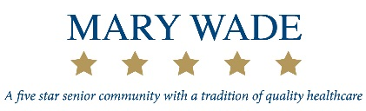
For Immediate Release
A Statement from Mary Wade Home

New Haven, CT, April 10, 2019: -- Cases of COVID-19, the illness resulting from the novel coronavirus, have been diagnosed at the Boardman Residential Care Home at Mary Wade. David Hunter, President & CEO of Mary Wade Home, has issued the following statement:

“The residents were admitted to Yale-New Haven Hospital and their families notified according to our policy; as required, we have notified city and state public health officials, and are following procedures recommended by the Centers for Disease Control & Prevention. There is no greater priority at Mary Wade than the health and well-being of our residents and the staff members who care for them; we are taking every step as recommended by public health authorities to contain the spread. We want to reassure residents, their families, our dedicated staff and our community that we are on top of the situation.

“At this time, our focus is on ensuring the safety and well-being of our residents and staff, and we are following proper infection control and emergency preparedness to ensure their safety and well-being. We are communicating all updates on a daily basis to our residents, their family members and employees through a multitude of internal communication channels, and will provide ongoing updates through our webpage and social media channels for families, media, and the greater community.

“We continue to offer every assurance to our residents, their families and our employees that Mary Wade will follow all recommendations and will act in the best interests of our entire community.“
# # #

About Mary Wade: Founded in 1866, Mary Wade is a senior care community serving New Haven County. Mary Wade provides long term skilled nursing, short term rehab, adult day care, and a residential care home for older adults in need. The mission at Mary Wade is to provide those in need with the highest quality medical and social programs, as well as supervised residential services in order to promote their individual abilities in a traditional, dignified and comfortable community of caring. For more information, visit www.marywade.org.

