DATAHAVEN ESTIMATES THAT SOCIAL DISTANCING TO COUNTER THE SPREAD OF COVID-19 HAS ALREADY SAVED 10,000 LIVES IN CONNECTICUT

Local officials throughout Connecticut congratulate residents, but stress importance of continued prevention efforts and attention to community needs

April 23, 2020
For Immediate Release

New Haven, CT – Residents following strict social distancing measures to counter the spread of COVID-19 have already saved the lives of 10,000 residents in Connecticut—more than the total number of deaths caused by heart disease and stroke combined each year—according to a DataHaven projection.

The number of lives saved by residents who have been avoiding non-essential travel is illustrated through a chart created by Camille Seaberry, Senior Research Associate at DataHaven.

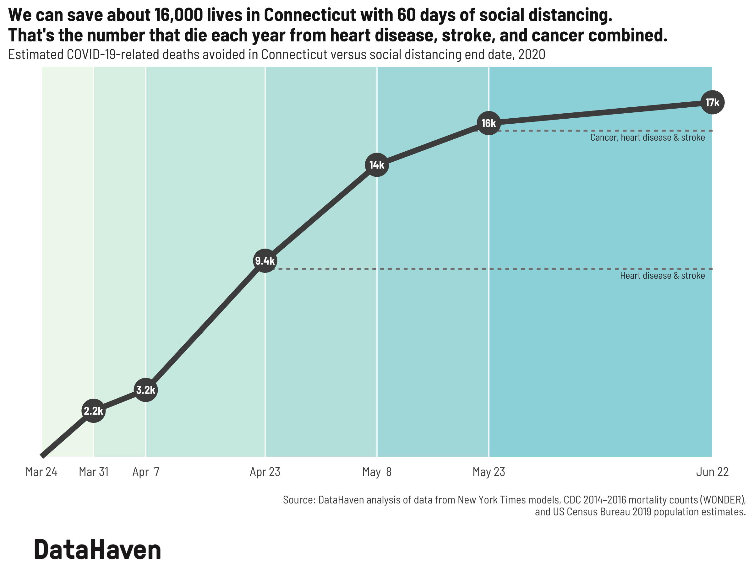

Faced with the rapidly spreading novel coronavirus (SARS-CoV2), the Centers for Disease Control recommended nationwide social distancing on March 15. In Connecticut, state-wide restrictions on non-essential travel and gatherings were enacted on March 16, and non-essential businesses were ordered to close on March 23. Social distancing is the practice of maintaining physical distance between people by avoiding large gatherings or crowded spaces in order to slow the spread of an infectious disease.

Mobility data from Descartes Lab shows that Connecticut residents began reducing their travel several days before March 15, as concerns grew. Based on cell phone data measuring the number of miles individuals moved each day, Connecticut residents’ average mobility steadily declined from 4.7 miles on March 12 to less than half a mile on March 23.

The DataHaven estimate of lives saved is based on a methodology designed by Community Information Now at the UTHealth School of Public Health, and utilizes data from a New York Times (NYT) epidemiological model of COVID-19-related infections and deaths in the United States. The NYT model was used to estimate the projected number of infections and deaths based on various durations of adherence to the restrictions implemented in Connecticut as of March 23: closing of all non-essential businesses, cancellation of non-essential public community gatherings, keeping six feet away from other people, and limits on close-contact outdoor recreational activities. These estimates were compared to the estimated number of deaths that may have occurred with no social distancing, and the difference between these figures is the estimated number of lives saved. Connecticut’s infection and mortality rates were assumed to match those of the United States.

In the month since the strictest social distancing guidelines went into place, DataHaven estimates that the state has seen 10,000 fewer deaths than were predicted by the NYT model.

While social distancing measures have been effective in reducing potential deaths due to COVID-19, easing these restrictions is not yet advised.

In a virtual town hall on Tuesday, April 21, Yale New Haven Health’s (YNHH) Chief Clinical Officer Thomas Balcezak, MD, said the state’s coronavirus hospitalizations are currently likely “very close to where we will peak,” according to a New Haven Independent report by Thomas Breen. “The fact that it keeps getting later is actually good news,” he said. “It means that social distancing is working and we’re flattening the curve and pushing that peak date out” so that the hospital system is not overwhelmed.

The number of new cases of COVID-19 in Connecticut continues to increase. According to a new interactive report by DataHaven, “COVID-19 in Connecticut: Data Analysis,” there were 5,660 newly-reported cases of COVID-19 in Connecticut from April 17 to April 22, compared to 4,774 newly-reported cases during the 5 days prior to that, a 19% increase. As of April 22, Stamford, Norwalk, Danbury, West Haven, Bridgeport, New Haven, Bloomfield, Greenwich, and Woodbridge currently had the highest per capita rates of confirmed cases, according to DataHaven’s analysis. About 2,000 people are currently hospitalized in Connecticut, and according to the New Haven Independent report, out of the 450 people hospitalized in New Haven, 113 were in the intensive care unit (ICU) and 72 were on ventilators. Frontline health workers are also particularly at risk: Approximately 1,000 of the 27,000 employees at YNHH have either tested positive or are symptomatic, according to the New Haven Independent report. According to the hospital’s leadership, once the state reaches 14 days of declining coronavirus-related hospitalizations, it will be past its peak.

For now, local health officials and mayors are working to remind residents that the stakes for social distancing are still high.

“Social distancing enables us to ‘break the chain of infection’ as it mitigates opportunities for COVID-19 to spread to others, who in turn, may infect many more. Without social distancing and with limited measures/actions, this can rapidly snowball into tens to hundreds to thousands of additional cases burdening the healthcare system with possible fatalities that could have been easily prevented. I applaud the efforts of all communities that continue to maintain social distancing as we do not live in a vacuum, and everyone’s actions can directly influence the potential of COVID-19 exposure for others, especially those most vulnerable to serious complications, ” said Brian Weeks, Epidemiologist for the City of New Haven Health Department.

“The biggest danger we have is a false sense of complacency. The fact remains we are still seeing people test positive, and still have people who may be unknowingly transmitting the virus. We are not out of the woods yet. I know people are eager to try and get back to normal. We must listen to the medical professionals and experts who are studying COVID-19 on when it will be safe to slowly reopen. The best thing we can do to save lives and slow the spread of this virus is to continue practicing physical distancing," said Norwalk Mayor Harry W. Rilling in response to the data.

Jennifer Muggeo, MPH, Deputy Director of the Ledge Light Health District in New London, stresses that continued prevention efforts, including attention to how health outcomes differ by community during this time, are also essential. "As we receive these data as good news, we must acknowledge the efforts that are still required. The collective efforts of our community members to be physically distant from each other, from their loved ones, from their regular routines have saved lives and we must continue these efforts. We must also focus a sharp eye on the data that highlight the significant inequities experienced by communities of color and assure that response and recovery efforts begin to address these. Structural racism is the direct cause of disproportionate rates of co-morbidities and life circumstances that increase the risk and incidence of serious illness and death from COVID-19 in these communities. Additionally, due to economic and housing inequities, people of color in our communities are less able than their white counterparts to engage in physical distancing. We have an urgent and overdue responsibility to address racism as a public health issue."

According to DataHaven’s projections based on NYT data, extending social distancing by just two more weeks would save 4,000 more lives. One more month of social distancing would save 6,000 lives.

“While the coronavirus pandemic is creating significant hardships and poor health outcomes for so many communities across our state, we should also take a moment to congratulate residents for their collective efforts to save so many of their neighbors’ lives,” said Mark Abraham, Executive Director of DataHaven.

-

Contact / About DataHaven

Mark Abraham, Executive Director, DataHaven
Email info@ctdatahaven.org
Telephone 203-500-7059

DataHaven (ctdatahaven.org) is a non-profit organization with a 25-year history of public service to Connecticut communities. The organization collects and shares information on well-being, equity, and quality of life in order to empower all people to create thriving communities.

Thomas Breen. April 21, 2020. “1K YNHH Employees Test Positive Or Symptomatic.” New Haven Independent. https://www.newhavenindependent.org/index.php/archives/entry/421_ynhh_update/
DataHaven. COVID-19 in Connecticut: Data Analysis. (April 22, 2020 update). Updated daily. https://www.ctdatahaven.org/reports/covid-19-connecticut-data-analysis
DataHaven. COVID-19 in Connecticut: Data Analysis. (April 22, 2020 update). Updated daily. https://www.ctdatahaven.org/reports/covid-19-connecticut-data-analysis.

