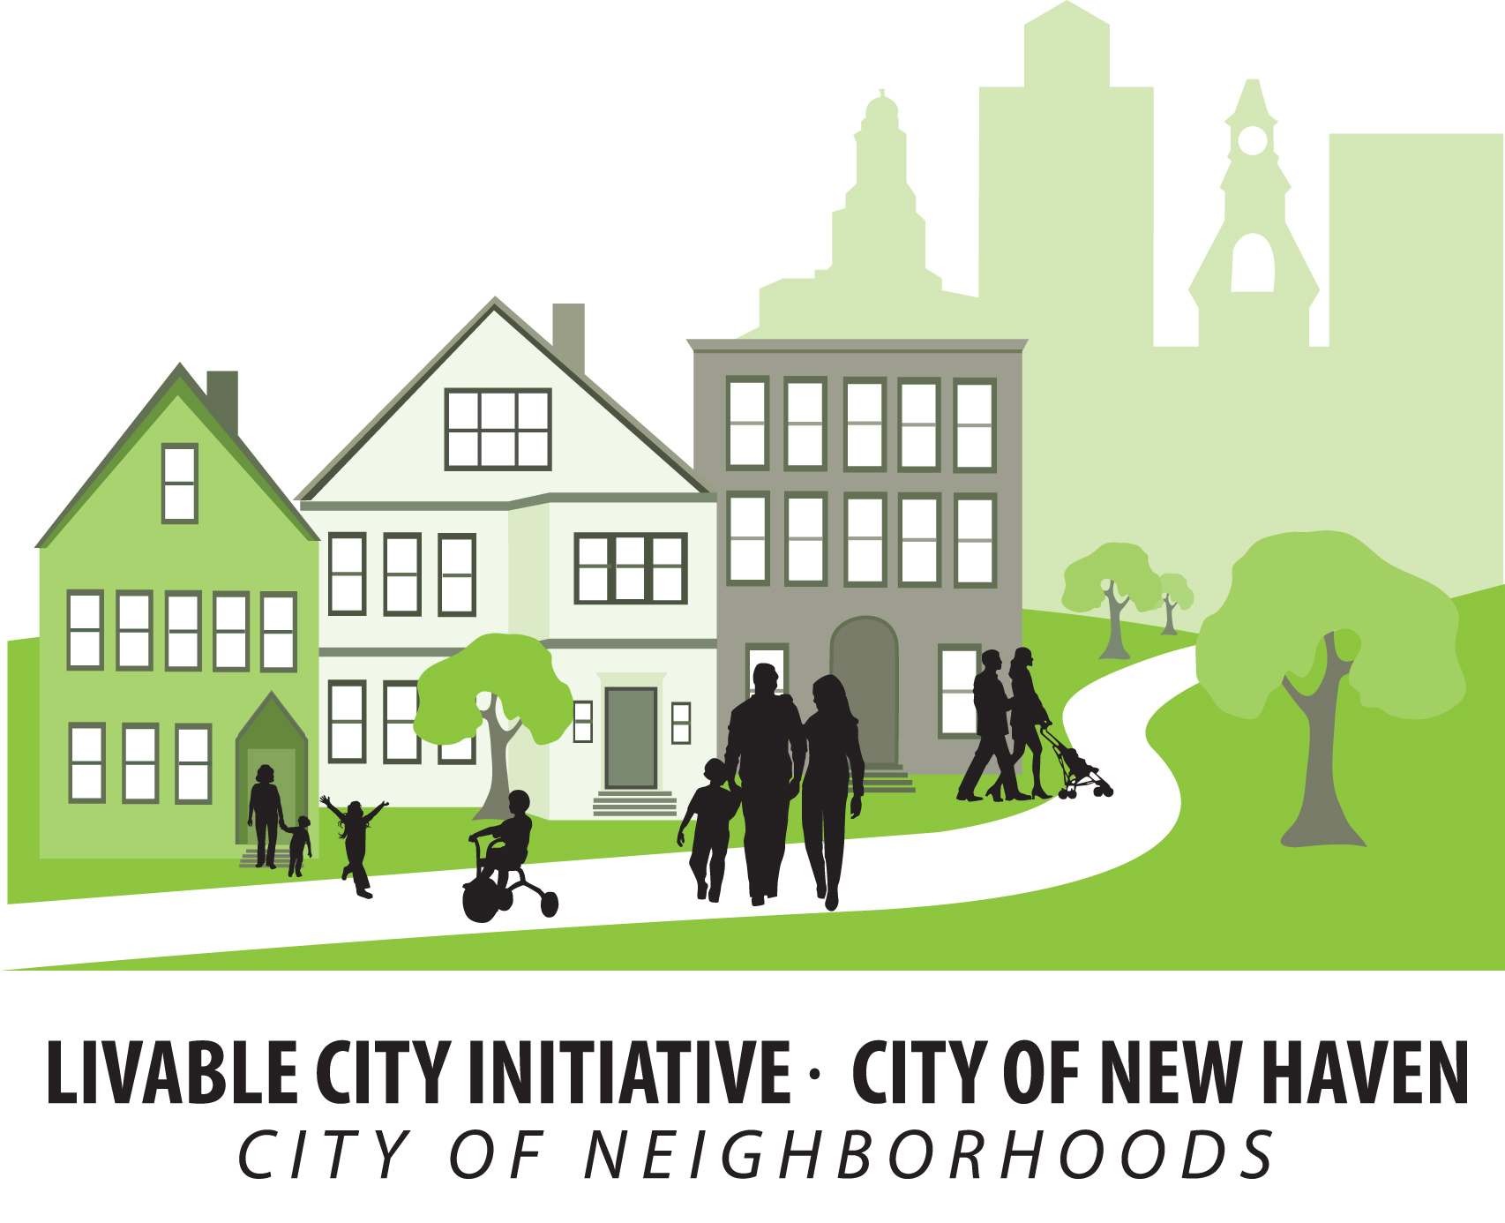 | CITY OF NEW HAVEN  Justin Elicker, Mayor  LIVABLE CITY INITIATIVE  165 Church Street, 3rd Floor  New Haven, CT 06510  Phone: (203) 946-7090 Fax: (203) 946-4899 | 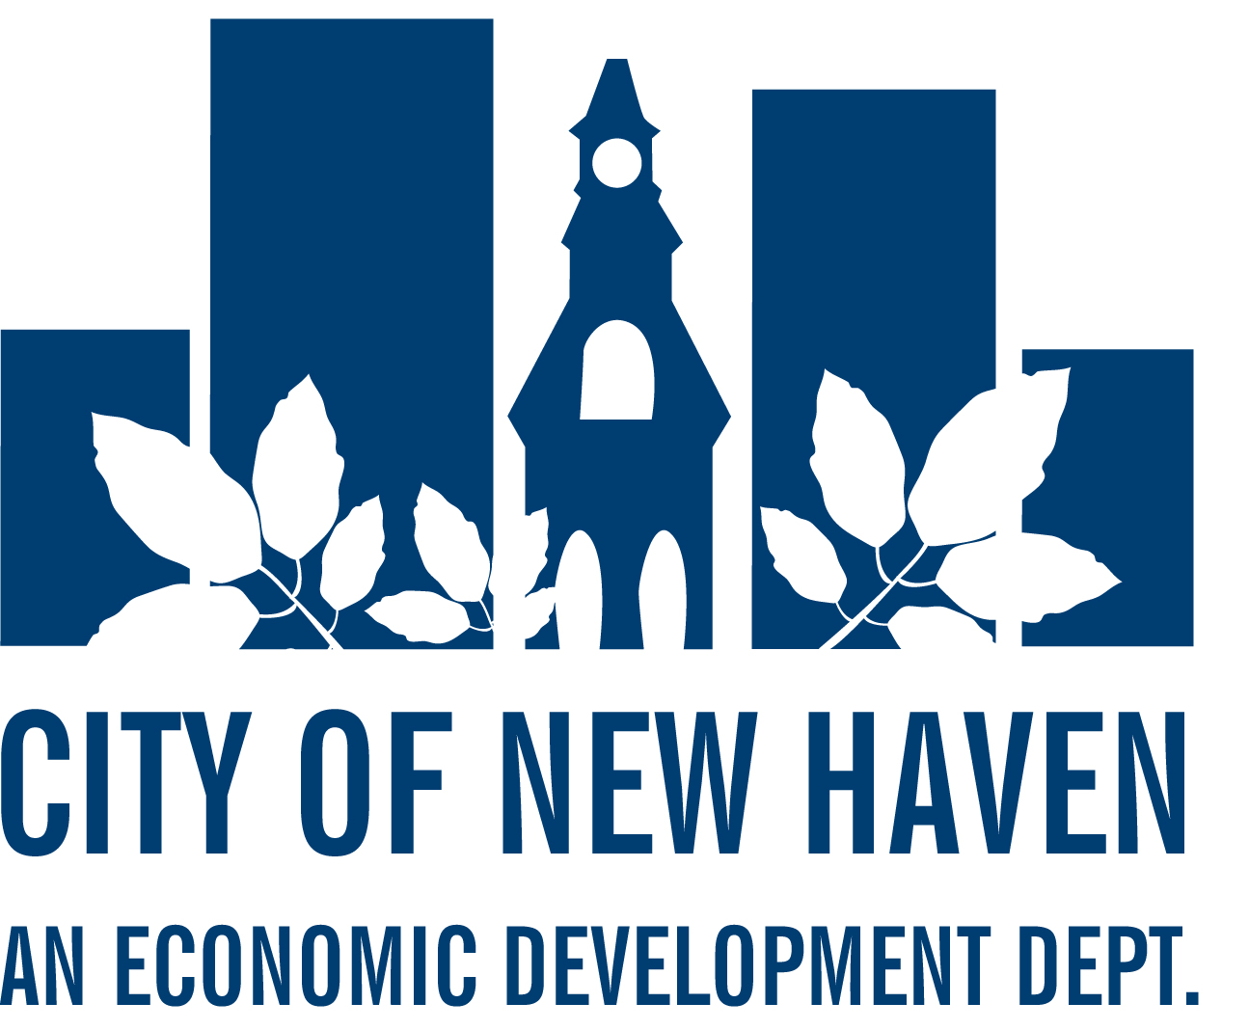
Arlevia T. Samuel  Acting Executive Director |  | Michael Piscitelli  Economic Development Administrator

October 18, 2020

The Honorable Alder Tyisha Walker-Myers
President, Board of Alders
City of New Haven
165 Church Street
New Haven, CT 06510

RE: DEVELOPMENT AND LAND DISPOSITION AGREEMENT BETWEEN THE CITY OF NEW HAVEN AND CONNCORP, LLC FOR THE CONVEYANCE OF REAL PROPERTY KNOWN AS PORTIONS OF DIXWELL PLAZA, NEW HAVEN, CONNECTICUT

- Suspension Agenda Requested

Dear Honorable President Walker-Myers:
I am pleased to submit for the Board’s consideration this Development and Land Disposition Agreement (DLDA) with CONNCORP, LLC (“the Developer”) concerning the City of New Haven’s interests at the Dixwell Plaza.
As you know, the Dixwell Plaza has been in a deteriorating condition for many years with high vacancy rates and substandard property maintenance. The Developer has assembled financing to acquire all of the condominium units which comprise Dixwell Plaza, including the City’s interest in the Stetson Library and the New Haven Police Substation. Once complete, the Developer proposes to fully redevelop the site as a mixed-use, mixed-income community in a manner consistent with attached concept site plans and marketing materials.
The DLDA sets forth the terms and conditions for the sale of the City’s interests and release of other rights in public ways and common areas. Notable provisions include,
- The Developer shall build a minimum of 150 housing units and 50,000 sf of commercial space within five (5) years.
- A minimum 20% of the housing units shall be affordable, 15 units at 60% AMI and 15 units at 80% AMI.
- The purchase price shall be $750,000, with $50,000 reserved for the Q House development fund.
- Construction and Small Contractor opportunities shall be made available consistent with City Ordinances 12½ and 12¼ as well as a resident construction workforce goal of 25%.
- Lease back provisions will allow the Stetson Library to remain on site until April, 2021 and for a full return of the NHPD substation when the new building is ready to open. Stetson will move across the street to the new Q-House.
As a more general point, the ConnCORP team consists of leaders in our community with a demonstrated commitment to inclusive growth and community development, highlighted by ConnCAT’s nationally-recognized programs at Science Park. The vision for Dixwell Plaza is in keeping with our overall efforts to revitalize Dixwell Plaza in a manner that builds a stronger community and I look forward to sharing this proposal in more detail at the committee hearing.
Thank you for your time and attention to this matter. If you have any questions, please do not hesitate to call.
Very truly yours,

Arlevia T. Samuel
Acting Executive Director

enclosures
cc: Taijah Anderson, Office of the Mayor
Michael Piscitelli, EDA
file

