|  |  |  |
| --- | --- | --- |
| CITYSE~2 | **CITY OF NEW HAVEN**  **BUILDING DEPARTMENT**  *200 Orange Street 5th Floor*  *New Haven, CT 06510*  *Phone: 203-946-8045* | edlogo_dept_color |

**ELECTRICAL PERMIT**

Construction Cost: $275000

Permit Fee: $8341.50

Certificate Fee: $  
\_\_\_\_\_\_\_\_\_\_\_\_\_\_\_\_\_\_\_\_\_\_\_\_\_\_\_\_\_\_\_\_\_\_\_\_\_\_\_\_\_\_\_\_\_\_\_\_\_\_  
 **TOTAL FEE: $8341.50**

Applicant Name: Sean Liston

Contractor Name: Sean Liston

Address: 418 Short Beach Rd. EAST HAVEN CT 06512

**Permit No**: **E-20-00617**

**Parent Pin**: **B-20-00051**

|  |  |  |  |  |  |
| --- | --- | --- | --- | --- | --- |
| Use Group(s): |  |  |  |  |  |
| Construction Type: |  |  |  |  |  |

This certifies that 66 NORTON LLC has permission to erect, alter

or demolish a building on: **66 NORTON ST** as follows:

Wire all 41 apartments containing 1.2 and 3 bedroom units as identically as follows: Romex wiring to be used throughout apartments using plastic boxes on wood studded walls. Center ceiling lights or old work recessed lights to be used dependent on location.All bathrooms to have exhaust fan light combination controlled at doorway, vanity light controlled on vanity counter top and GFCI next to vanity switch. Each unit to contain a main lug 24 circuit fed by SER cable. All units to have electric baseboard heating controlled individually per room by wall mounted thermostat. All units to have 120 volt smoke and combination detectors to code throughout apartment. All devices to be tamper resistant. All breakers to be arc fault protected where indicated by code. Common areas to have constant lighting in accordance with NEC, including exit signs, emergency lights, and combinations in hallways, stairwells and exterior fire escapes. Existing low voltage smoke detectors to be utilized in common areas to be reused when verified working properly. Exterior lighting to be throughout perimeter of building controlled via photo sensors. Service to be 42 modular meter bank, location and size still to be determined upon site meeting with UI. CSBC 2018.

**All Other Work and MEPS Require Separate Permits**

Provided the person accepting this permit shall in every respect conform to the terms of the application therefore on file in this office, and to the provisions of regulations or ordinances relating to the Location, Inspection, Alteration and Construction of Buildings in the City of New Haven.

*Note: The recipient of this permit accepts this permit on the condition that as owner or as agent of the owner, he/she agrees to comply with all Building & Zoning Regulations of the City of New Haven & State Statutes of the State of Connecticut regarding the use, occupancy, & type of building or structure to be constructed, added to, demolished, or altered. The recipient also agrees that this building is to be located the proper distance from all street lines, all property yard lines, & required distances from all other zones & is located in a zone in which the building & its use is allowed or has been approved*

Date: 04/22/2020

Review for Compliance by:

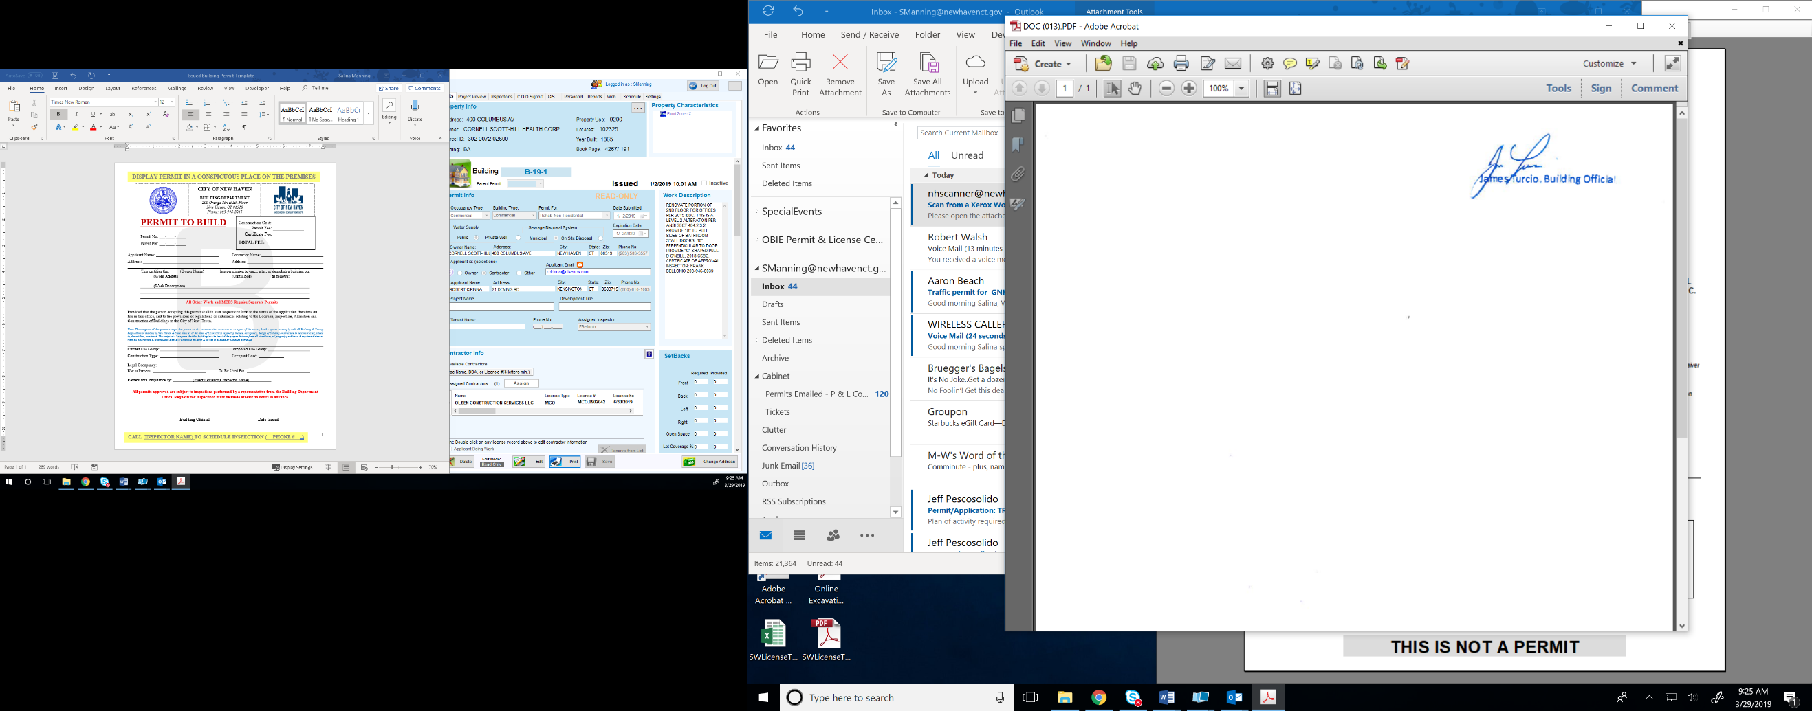**All permits approved are subject to inspections performed by a representative from the Building Department Office. Requests for inspections must be made at least 48 hours in advance.**

**\_\_\_\_\_\_\_\_\_\_\_\_\_\_\_\_\_\_\_\_\_\_\_\_\_\_\_\_\_\_\_** Date Issued: 05/12/2020

