ORDER OF THE BOARD OF ALDERS OF THE CITY OF NEW HAVEN APPROVING AN AMENDED AND RESTATED LEASE AND OPERATING AGREEMENT BY AND BETWEEN THE CITY OF NEW HAVEN AND TWEED NEW HAVEN AIRPORT AUTHORITY and ORDINANCE AMENDMENT REPEALING SECTION 4-70 OF THE CODE OF GENERAL ORDINANCES

Background Information July 6, 2021
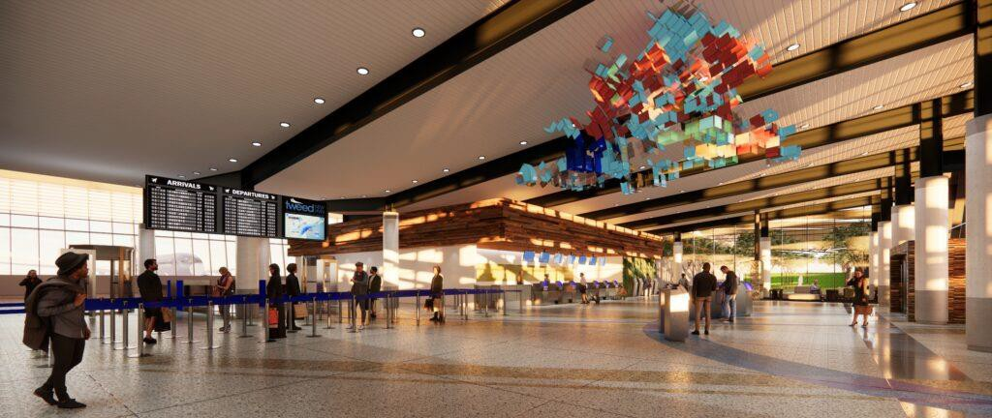

Summary

The land upon which Tweed-New Haven Airport (the “Airport”) is situated is owned by the City of New Haven (the “City”), leased to Tweed New Haven Airport Authority (“the Authority”) and operated under a management contract with Avports, an airport management services provider.

Earlier this year, the Authority and AvPorts announced a series of initiatives, namely,

- AvPorts and the Authority agreed to the terms for an agreement for AvPorts to operate and manage the Airport through a long-term sub-lease agreement. The agreement will include provisions for financial contributions to capital improvements and air service development to support the economy of south- central Connecticut.

- An approach to capital improvements as recommended in the updated Airport Master Plan. In summary, AvPorts will carry out projects including extension of the main runway 2-20 and construction of the new passenger terminal and parking garage on the east side of the Airport property through a combination of federal grants and private investment.

- The launch of a new commercial air service, Avelo Airlines, which will make the Airport its first East Coast base. Avelo will station three 737 aircraft at the Airport by year end and generate local employment for over 100 crewmembers.

To implement these initiatives, it is necessary to amend and restate the above- mentioned lease with an Amended and Restated Lease Agreement (“the Amended and Restated Lease”) between the City and the Authority as well as to address an outdated provision of the City’s Code of Ordinances related to the weight of aircraft.

If approved, these actions will enable the Authority to enter into the long-term sub- lease agreement with AvPorts and to move forward with the updated Master Plan in a manner that provides for growth in passenger air travel in a responsible manner relative to the surrounding community and the environment.

The following Q&A provides additional information on the Amended and Restated Lease as well as the context for moving forward with the Authority and AvPorts on implementation.

What are the key terms of the Amended and Restated Lease relative to the updated Master Plan and the new initiatives?

The City entered into the current lease with the Authority in 1998 and the lease is set to expire on June 30, 2023 (with an option to extend for another 25 years). With this Amended and Restated Lease, the term would be extended to June 30, 2064.

The Authority will continue to be responsible for operating the Airport including the implementation of capital improvements programs such as those articulated in the updated Master Plan and ensuring safety and regulatory compliance with the Federal Aviation
Administration (“FAA”). The Authority has contracted with AvPorts for operation and

management of the Airport since 1998. That contract will be extended for the duration of the City-Authority lease.

The Authority shall be allowed to sub-lease portions of the Airport to AvPorts, and assign certain revenue streams in order to support private financing, capital improvements and general operations.

The City and the Authority have agreed to a “Project” which entails primarily (1) design and construction of a new East Terminal and (2) extension of the main runway 2-20 to 6,635 linear feet. Performance Standards (which will be set forth in the appropriate legal documents) relate to sustainable development and responsible neighbor initiatives to deal with low-flying aircraft, traffic and noise as well as stormwater management, wetland restoration and coastal habitat enrichment. There will be a new environmental stewardship advisory committee including three New Haven residents and two East Haven residents; and creation of a sustainable development plan. The Performance Standards also restate AvPorts’ commitment of $5.0 million for noise and traffic mitigation and community enrichment.

From a financial perspective, the Amended and Restated Lease commits the City to its Fiscal Year 22 operating subsidy of $325,000 and a FY23 subsidy of half that ($162,500), which would need to be appropriated by the Board of Alders as part of its regular FY23 budget process. For FY24 and beyond, the Authority does not expect to need, and shall not be entitled to, operating subsidies from the City because it expects that the AvPorts sub-lease will generate sufficient revenue to make subsidies unnecessary.

By way of background, prior to the creation of the Authority by state statute in the late 1990s, the Airport was operated by a City department. Since creation of the Authority, the City has contributed over $12.0 million in total operating support over the years.

Why does the weight restriction need to be addressed?

A City ordinance currently sets a weight limit for aircraft using the airport of 160,000 pounds. Under FAA regulations, only airport operators can impose weight limits on runways and, even then, they can impose such restrictions only if they are supported by detailed technical analysis. Not only has the City not been operator of the Airport for the last 23 years, but we can find no technical basis for imposing the weight limit today. Therefore, the City weight ordinance is not

enforceable. The Authority, as part of the Master Plan, is conducting a technical analysis, acceptable to the FAA, which will determine the new weight-bearing capacity of Runway 2/20. It is likely to be higher than the Ordinance limit. Available technical data shows that the runway as it exists today can accommodate Avelo’s planned 737 aircraft.

What is in the new Master Plan and what is timeline for improvements at the Airport?

The updated Master Plan is a document required by the FAA to justify capital improvements. Key aspects of the document relate to the Authority’s proposals for (1) extending the main runway 2-20 to 6,635 linear feet; (2) building a new passenger terminal to the east side of the airport with space for 4-6 gates; and (3) implementing sustainability measures including stormwater, noise and traffic mitigation. The Authority has initiated the federally required environmental review process which is the next required step before these improvements can be made.

In order to accommodate Avelo in the short-term and to welcome new customers to the Airport, improvements are needed to the current terminal and administration building. In August 2021, the City Plan Commission is expected to review plans and hold a hearing concerning interim parking improvements.

Construction of the temporary renovations and improvements to the current terminal and parking as well as the move to a new terminal on the east side are expected to be completed within three years, subject to environmental permitting and design reviews.

What is the proposed sub-lease arrangement with AvPorts?

AvPorts, on behalf of the Authority, will manage and operate the airfield facilities (runways, taxiways). AvPorts will lease the landside facilities (terminal, roadways and parking) from the Authority, and will then enter into arrangements with airlines, rental car companies, concessionaires, etc., to use the terminal facilities. AvPorts will have the right to collect the revenue from the Airport operations, will pay its operating and capital expenses, and will pay rent to the Authority as well as a share of revenues above certain thresholds.

AvPorts’ operations AvPorts will be subject to the agreed-upon performance and operating standards with Authority oversight. AvPorts will report regularly to Executive Director and the

Board of the Authority to ensure the Airport is operated in accordance with industry practices and FAA, US DOT, and Homeland Security / TSA requirements and regulations.

During operations, AvPorts will pay rent and will make revenue-share payments to the Authority. The Authority will use this revenue to fund its operations and oversight functions and any additional funds would be placed in a special airport reserve fund for unforeseen needs or future capital needs. AvPorts will also make payments to the Authority to share the proceeds in the event of certain transfers of ownership interests in the company. As required by federal law, all money that the Authority receives from AvPorts must be used only for Airport purposes.

Who will pay for the improvements?

AvPorts will be responsible for securing funding the runway extension, the existing terminal renovations, new East Terminal and other improvements. The runway is expected to be funded mostly from grants by the FAA; but other improvements are expected to be funded with equity contributed by AvPorts and debt that will be an obligation of AvPorts. The debt will be non-recourse to the Authority and the City, meaning that if AvPorts defaults on the debt, neither the Authority nor the City will be responsible for payment.

Why AvPorts?

AvPorts has been a trusted partner of the Authority for more than 20 years and has decades of experience operating and developing airports from coast-to-coast. AvPorts submitted an unsolicited proposal to the Authority to transform the Airport with a modest runway extension and a new terminal, which together will allow improved passenger service to more destinations, greater passenger convenience, enhanced airport safety, and significant economic and community benefit to the adjacent municipalities and region. AvPorts has a long and deserved reputation as a responsible member of the communities where it operates.

Today, the Airport loses money and needs subsidies from the City and the State. The current financial position of the Authority makes it impossible for the Authority to make improvements that would be necessary to attract passenger service without significant additional funding from the City and the State. Under the proposed lease, AvPorts will assume responsibility for all capital projects and operating expenses, transferring significant financial risk from the Authority, City, and State.

Will scheduled service at the airport increase?

The improvements are intended to accommodate the potential for increased demand for commercial air service for south central Connecticut. Most operations at the Airport are today, and will remain, general aviation (private operators). Therefore, the scheduled service will represent a small increase in overall operations at the Airport and provide a much-needed benefit to business and leisure travelers, including travelers who now fly in and out of New York City-area airports. Avelo Airlines is the first new carrier to announce plans to schedule service out of New Haven in many years and provides an early indication of future growth potential once the new terminal is constructed.

Does the plan address potential impacts and environmental protection?

AvPorts will be responsible for monitoring airport noise and enforcing FAA regulations and has agreed to continue to enforce the City’s noise ordinance. AvPorts will also be responsible for implementing a traffic calming plan to reduce neighborhood traffic impacts. AvPorts has agreed to supplemental funding in the event the FAA does not cover certain mitigation measures. This commitment includes $1.5 million for traffic, $1.5 million for noise attenuation and an additional $250,000 to address the specific concerns about noise related to general aviation traffic (eg- run ups and ground power units).

A number of environmental initiatives will be undertaken as part of the capital plan, including a new stormwater management plan, wetland and coastal habitat restoration, upgrades to the Morris Creek tide gates. On an ongoing basis, AvPorts will have a sustainable airport development plan consistent with industry best practices. There will be a new Environmental Stewardship Advisory Council to work with Authority and AvPorts officials to maintain a high standard of environmental protection.

Will personal and corporate planes still operate at the Airport?

Yes. Robinson Aviation is the fixed base operator at the Airport that provides services to these planes known as general aviation. The Authority is required by federal law to provide access to any aircraft that wishes to use the Airport. To address issues related to noise from general aviation, AvPorts will work with the flight school to minimize its impact and to ensure

compliance with regulations for low lying aircraft over congested areas. AvPorts will work with any fixed base operator at the Airport and the FAA to ensure compliance with regulations for general aviation operations.

How can residents connect residents to jobs at the Airport?

AvPorts will be required to maximize the participation of local business entities and meet established goals for DBE, M/WBEs, both in its initial construction, as well as in the ongoing operations of the Airport; develop and promote a robust Diversity Equity Inclusion program for all entities operating out of the Airport; develop a local job pipeline; and comply with City Ordinances 12½ and 12¼ for all projects that are not federally funded. AvPorts will develop a jobs pipeline initiative with New Haven Works for permanent jobs.

What are the overall economic benefits?

Improving the Airport will generate much-needed economic activity in the region, including the creation of up to 11,000 jobs and $47 million in state and local taxes in the long term.

