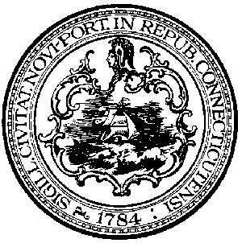 | City of New Haven  Justin Elicker  Mayor  Chief Administrative Officer | City Hall  165 Church St.  New Haven, CT 06510  (203) 946-7900  FAX (203) 946-7911

August 2, 2021

The Honorable Alder Tyisha Walker-Myers
President, Board of Alders
City of New Haven
165 Church Street
New Haven, CT 06510

RE: Order of the Board of Alders of the City of New Haven Approving an Agreement with Wonderland of Ice Associates for the Management, Operation and Maintenance of the Ralph Walker Ice Rink at Blake Field

Suspension Agenda Requested

Dear Honorable President Walker-Myers:

I am respectfully submitting for the Board’s consideration the above-referenced Agreement with Wonderland of Ice Associates (“Wonderland”) as the new operator of the Ralph Walker Ice Rink. Procurement of the new operator was done by competitive procurement (#2021-05-1377) and review by city staff and the Ice Rink Advisory Committee with the goal of having the new operator in place for the 2021-22 skating season beginning in October.

By way of background, Wonderland of Ice has over 30 years of experience in the industry, manages both the Wonderland of Ice in Bridgeport and the Norwich Ice Arena. The company and its leadership team have a demonstrated knowledge of the industry and operations of community ice rinks. Pursuant to terms of this Agreement, Wonderland will do business as Skate New Haven, with responsibilities for the day-to-day management and maintenance functions, launching a comprehensive programming effort to include learn to skate, learn to play hockey, special events and tournaments.

Consistent with the City’s recent capital improvement program and renewed focus on a first-class skating facility, the Walker Ice Rink will continue as the home ice facility for Albertus Magnus College as per prior agreement with the City. The Agreement is structured as a partnership with a base rental fee and a revenue sharing formula for general operations and concessions. The City will be responsible for most capital expenses in a manner similar to operations at the Alling Memorial Golf Course.

I am highly confident in Wonderland’s approach and trust that users of the new community programs and as well collegiate hockey players will find the Walker Ice Rink to be among the very best skating facilities in all of New England.

If you have any questions, please do not hesitate to call me direct at (203) 946-7903.

Very truly yours,
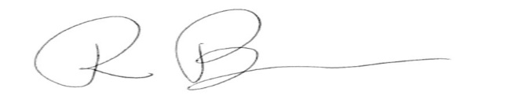

Rebecca Bombero
Deputy Chief Administrative Officer

